Aim: To perform data cleaning, transformation, and feature engineering on a dataset using Amazon SageMaker Notebook, and prepare it for further model training and analysis.
Theory:
- Amazon SageMaker Notebook:
A fully managed Jupyter notebook environment that simplifies data exploration, analysis, preprocessing, and machine learning model development on AWS.
- Data Preprocessing:
The process of cleaning and transforming raw data into a structured form suitable for model training. This includes handling missing values, encoding categorical data, scaling numerical features, and feature engineering.
- Feature Engineering:
Creating new features or modifying existing ones to improve model performance. This step enhances the predictive power of data.
- Amazon S3 (Simple Storage Service):
A cloud-based storage service that holds input and output data for SageMaker notebooks, ensuring scalability and easy data access.

Procedure:
Step 1: Launch a SageMaker Notebook Instance
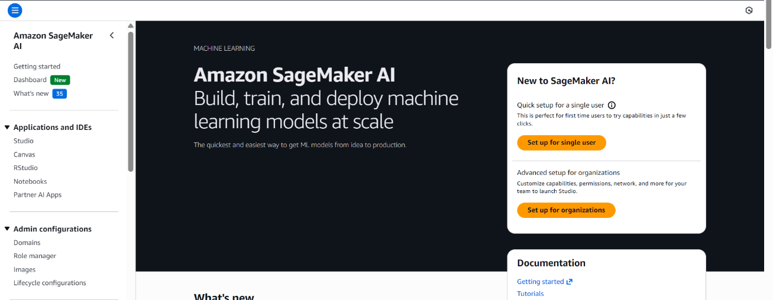
- Open the AWS Management Console and navigate to Amazon SageMaker.

- Create a new Notebook Instance (e.g., data-preprocessing-lab).
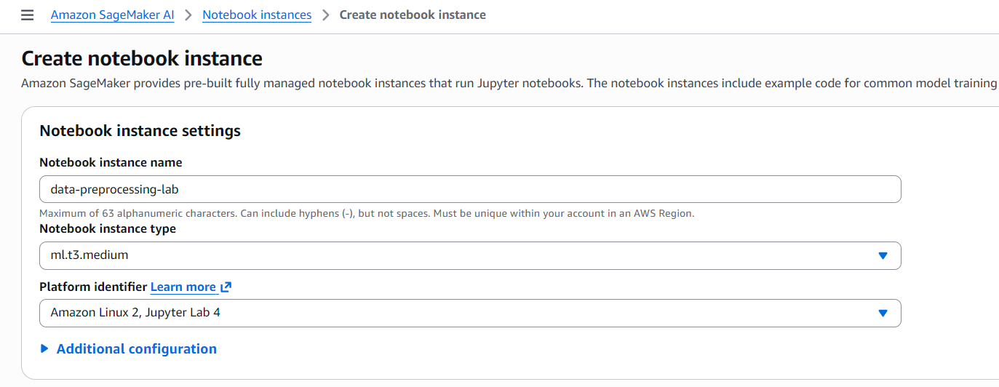
- Choose instance type ml.t3.micro (cost-efficient for small datasets).
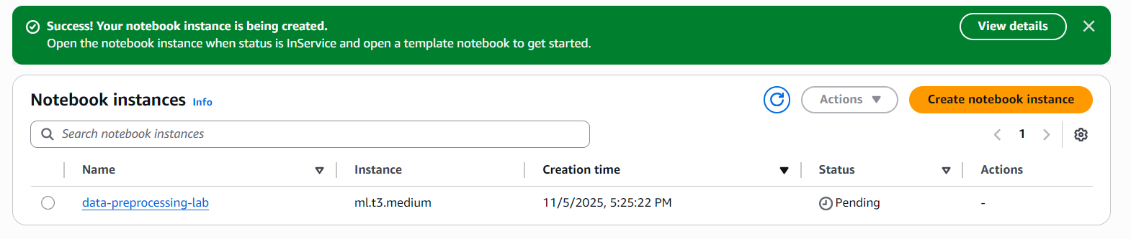
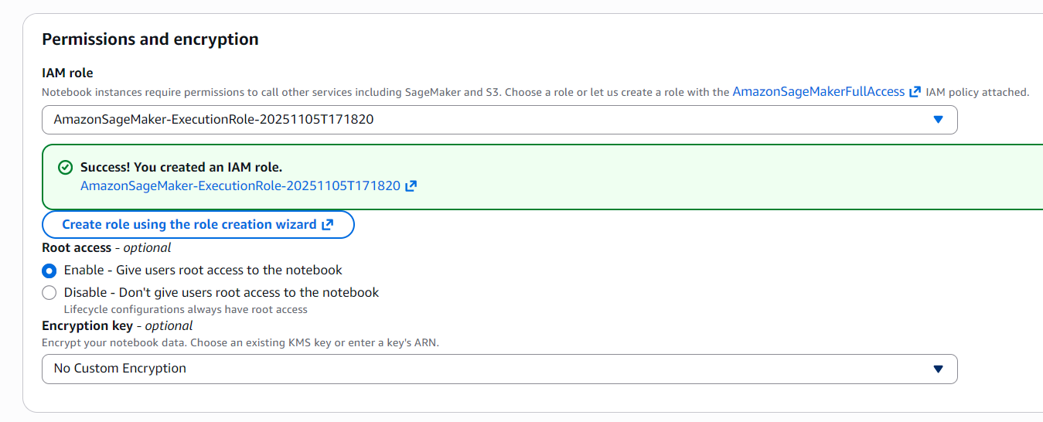
- Create an IAM role with S3 full access and attach it.

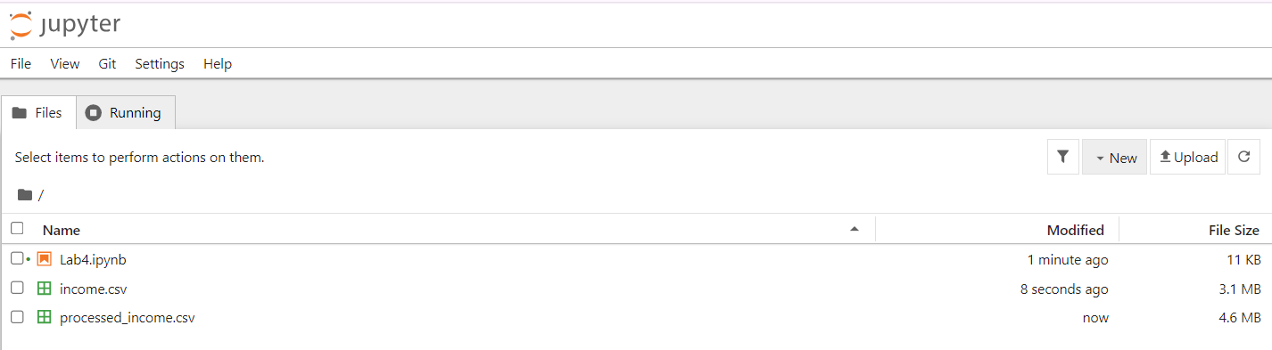
- Once the status is InService, click Open Jupyter to begin.

Step 2: Import Required Libraries
Step 3: Load the Dataset
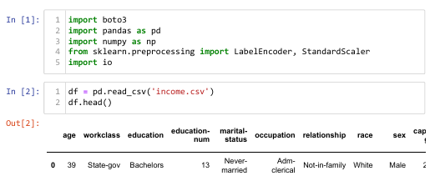
- Upload income.csv manually to the notebook or load it from S3.

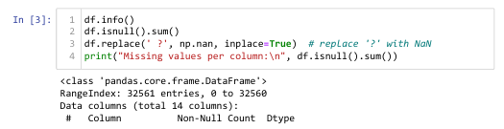
Step 4: Handle Missing Values

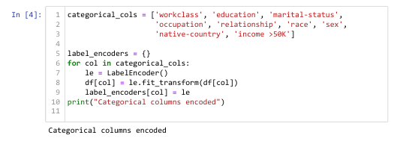
Step 5: Encode Categorical Variables

Step 6: Scale Numerical Features
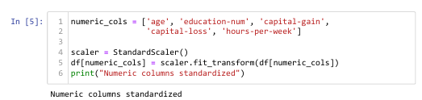

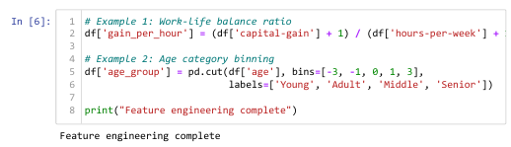
Step 7: Perform Feature Engineering

Step 8: Save and Upload Processed Data
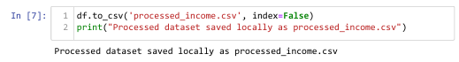

Conclusion:
In this lab, we successfully used Amazon SageMaker Notebook to perform essential steps of data preprocessing. We loaded the income.csv dataset, cleaned missing values, encoded categorical variables, scaled numerical columns, and engineered additional features to enhance data quality. Finally, the processed dataset was saved and uploaded to Amazon S3, preparing it for further machine learning tasks.
This practical demonstrated the power of SageMaker as a unified environment for data preparation and analytics in cloud-based machine learning workflows.

